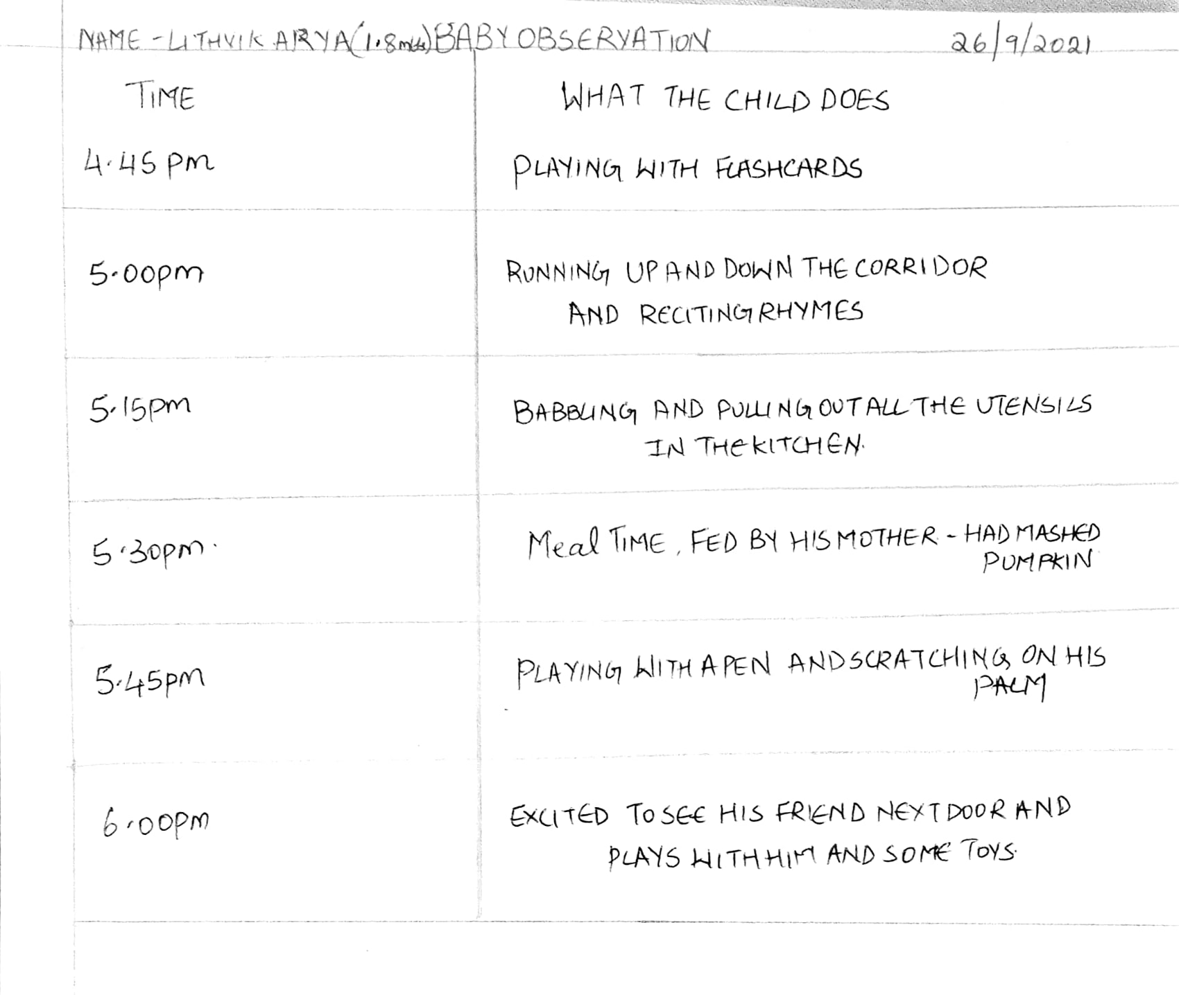

NAME OF THE BABY: LITHVIK ARYA

AGE: 1.8 years

HEIGHT: not known

WEIGHT: 9 kgs

EATING: South Indian staple food, fruits, vegetables, porridge

SLEEP: 1 nap during the day, sleeps at 11pm and wakes up at 6am

ROUTINE: Wake up, breakfast, playtime, rhyme time, nap, lunch, playtime, reading time, playing with neighbor, evening snack, rhyme time, playtime, dinner, play with dad, time for bed.

Language: babbles a lot, tries to communicate with a lot of sounds, can say 2-3 words in Tamil, and understands instructions in Tamil and a few words in English, Attends calls and says hello

Movement: Walks independently, loves jumping around and running, very active

INDEPENDENCE: plays independently, dependent on mother for all other things.

SOCIAL BEHAVIOUR: is very happy around people, tries to communicate with the guests, inquisitive by nature.

The overall experience was very interesting and informative.